Course: CS420 - Artificial Intelligence

01 – Search strategies for single agents

Question 1. Missionaries and Cannibals. Three missionaries and three cannibals are on one side of a river, along with a boat that can hold one or two people. Find a way to get everyone to the other side without ever leaving a group of missionaries in one place outnumbered by the cannibals in that place.
Consider a state as a tuple of values. Which values should be included in the tuple?

From this point, answer the following questions according to the definition of a state above.
Define the initial state and the goal state.

Define the action function in this representation.

What is the action cost in your successor function?

What is the maximum number of states in the state space, i.e., including illegal states?
What is the total number of reachable states?

Draw a diagram of the complete state space.
Question 2. Consider the following graph, in which S and G are the initial and goal states, respectively. The heuristic values are shown under the vertices’ names, while path costs are shown on every edge.
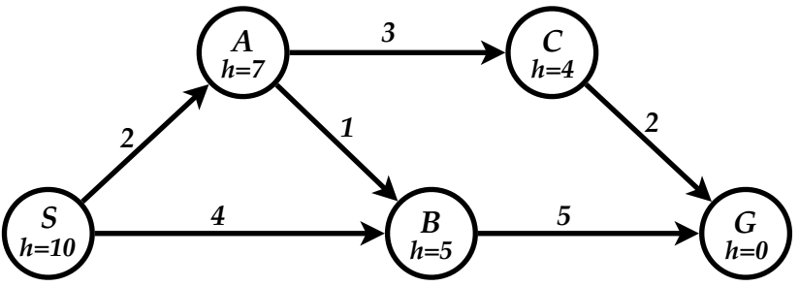
For each of the search strategies listed below,
(a) list, in order, the states expanded,
(b) list, in order, the states included in the found path, and
(c) show the final content of the frontier (recall that a state is expanded when it is removed from the frontier)
When all else is equal, nodes should be expanded in alphabetical order.

- Breadth-first search (BFS) (shown as an example)
List of expanded nodes: S A B
Path found: S B G
Frontier = { C }

- Uniform-cost search (UCS)
List of expanded nodes:
Path found:
Frontier = { }

- Depth-first search (DFS) (Avoid loops by remembering nodes on the current path).
List of expanded nodes:
Path found:

- Iterative deepening search (IDS)
List of expanded nodes for each limit: { } { } { }
Path found:

- Greedy best first search (GBFS)
List of expanded nodes:
Path found:
Frontier = { }

- A* search
List of expanded nodes:
Path found:
Frontier = { }

- Is the given heuristic admissible?

- Is the given heuristic consistent?

Question 3. The 4-queens problem requires you to place the four queens on a 4×4 chessboard such that no queen attacks another queen. (A queen attacks any piece in the same row or column or diagonal). Here are some important facts:
- The states are any configurations where all the queens are on the board, one per column.
- The moveset includes all possible states generated by moving a single queen to another square in the same column. The function to obtain these states is called the successor function.
- The heuristic function h(state) is the number of attacking pairs of queens.

- How many states are there in total? Explain your answer.

- For each state, how many successor states are there in the moveset? Explain your answer

- What value will the heuristic function h(state) return for state S shown aside? Explain your answer. | 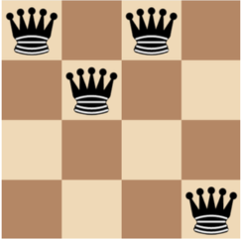

- Apply steepest ascent hill climbing to find a solution for the given problem, given the initial state S shown above. Draw the search tree with root node S, and, for each node on the tree, write down its h( ) value.

